EVS Placement description
Autonomia e Descoberta
Portugal

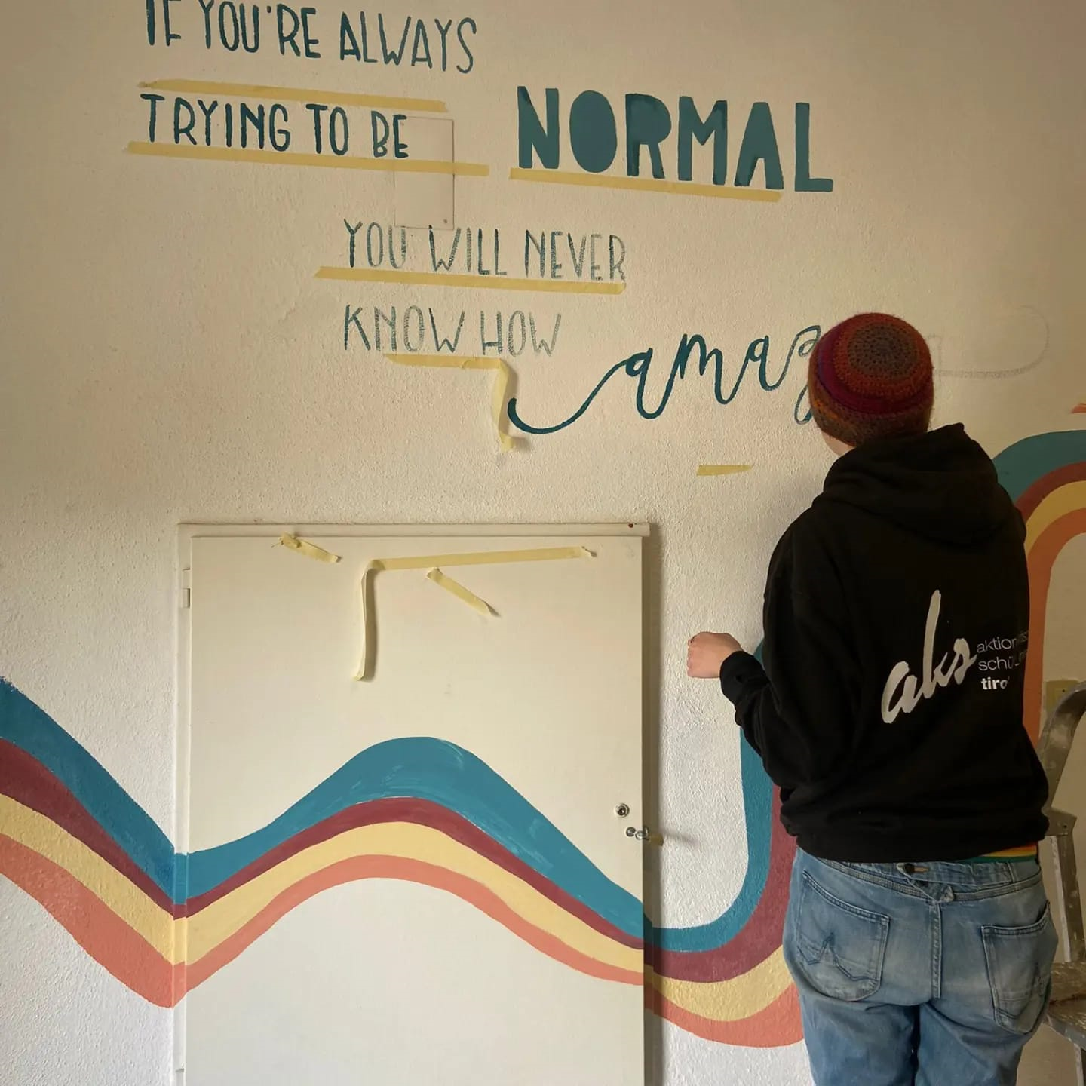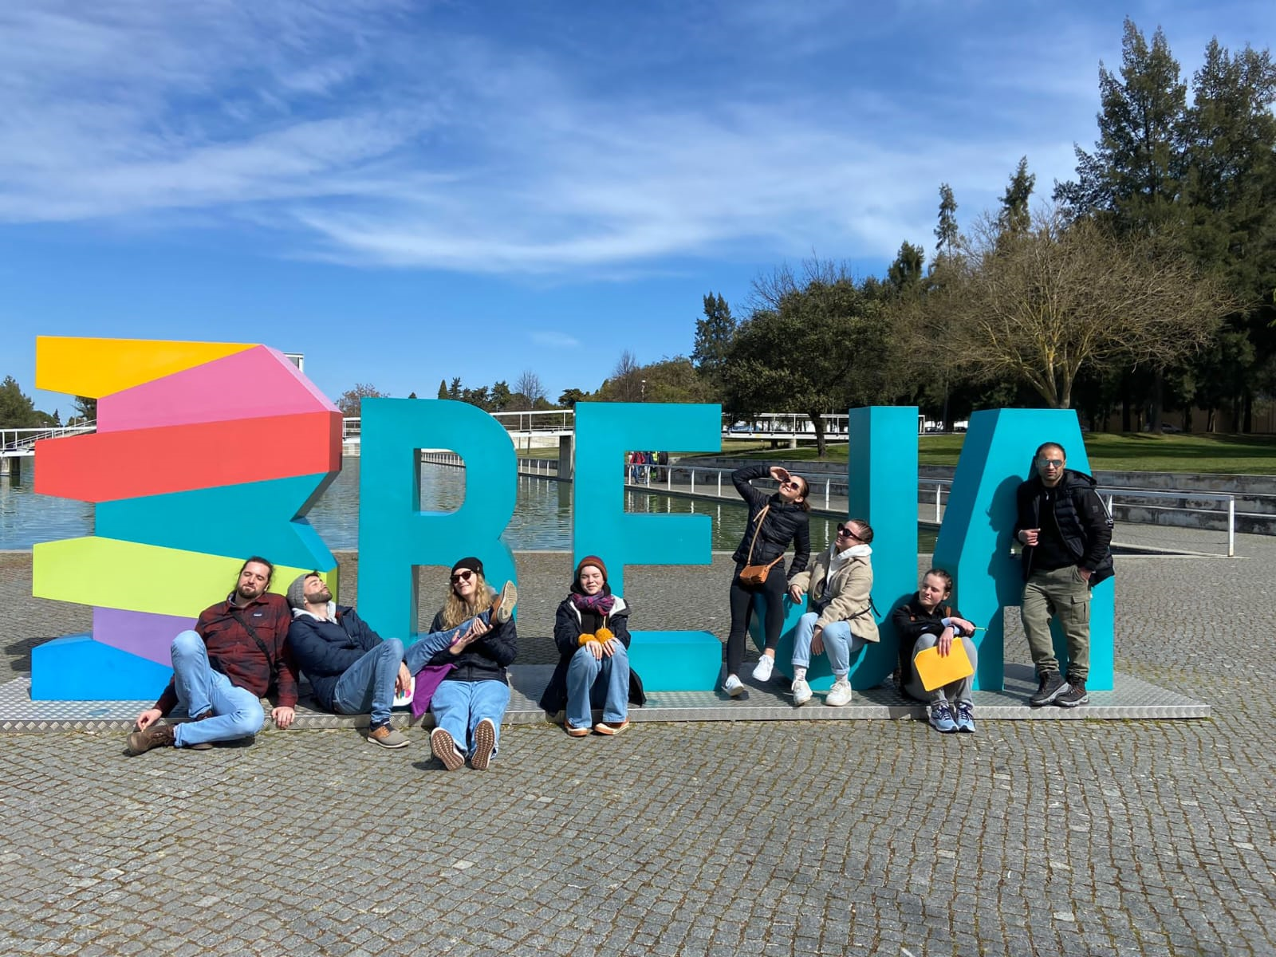
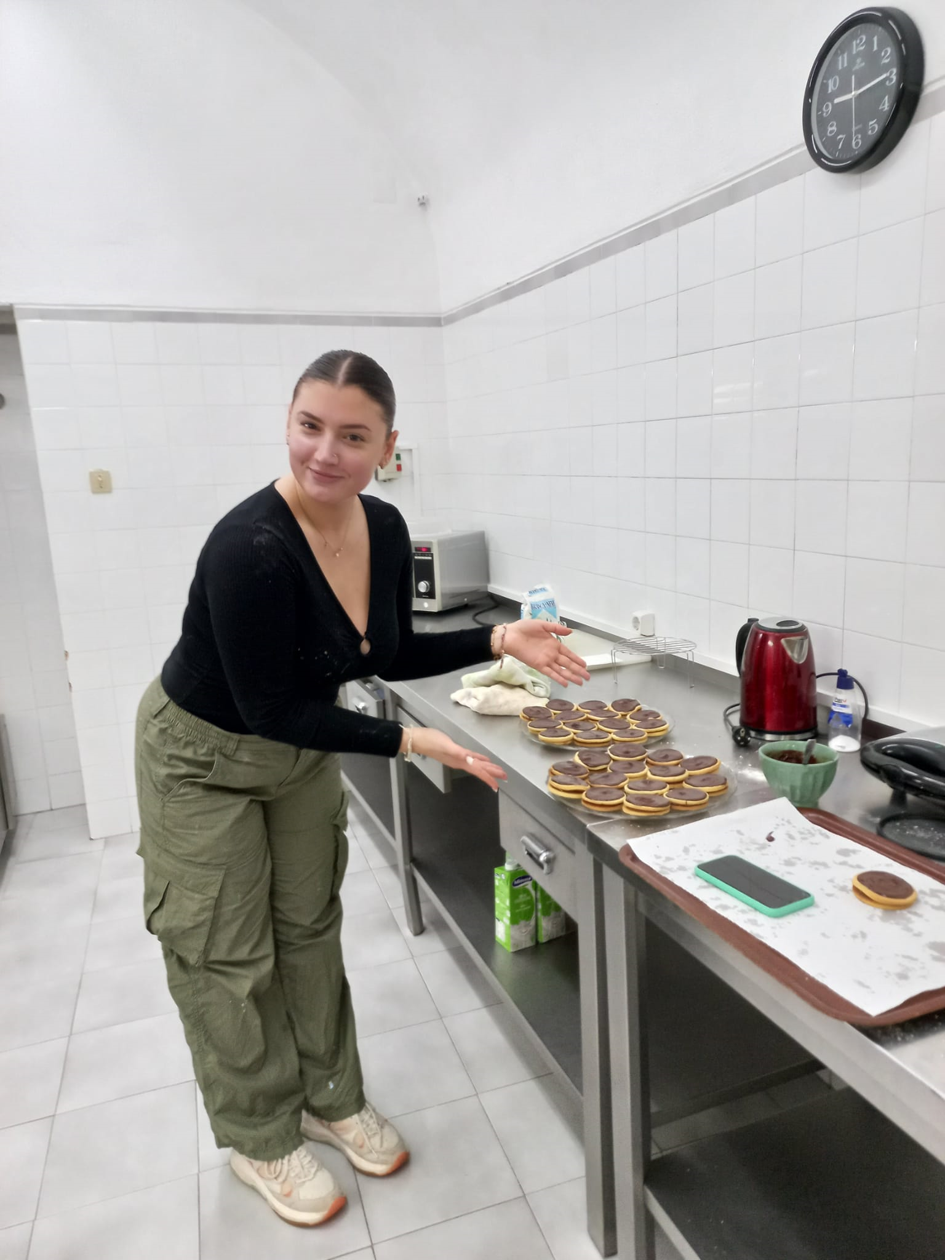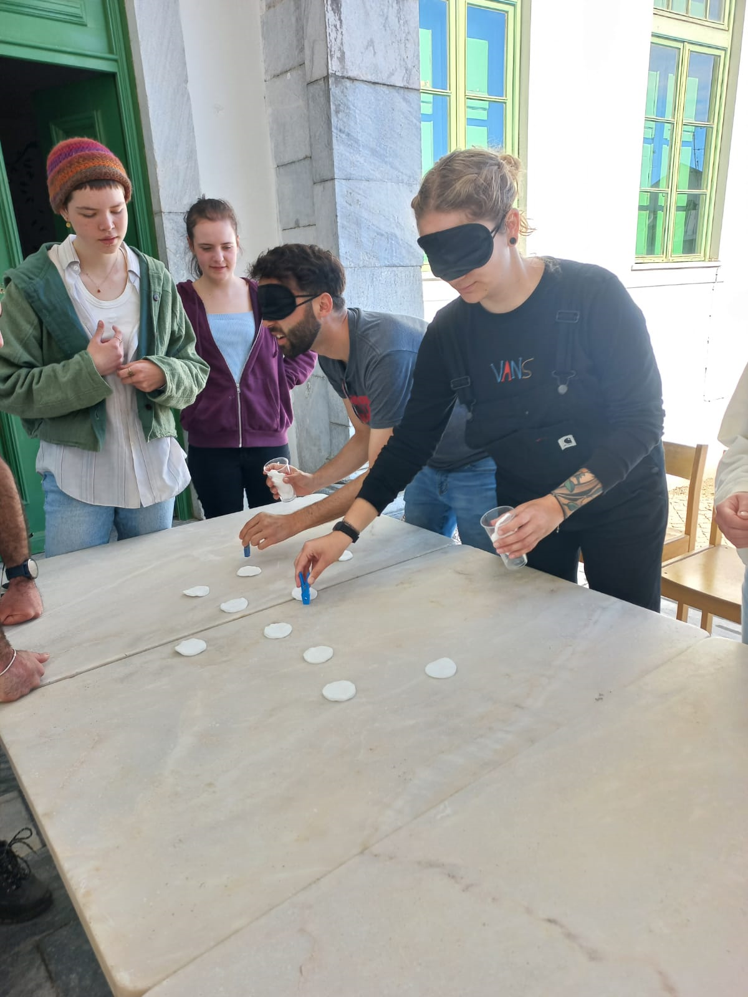

Information about the hosting organization
Description of the organisation
Autonomy and Discovery, CRL", is a cooperative with a recent history, it was founded at the beginning of 2012. A different reality is the experience of some of the founders, in the area of ​​working with young people for over 20 years and with programs international youth projects, since the pilot projects in the 90s.
With this introduction we don't want to say that we are "good". No, the meaning of this word is more in the sense of trying to explain why to start at that time. The explanation is easy. We think there are a lot of things, good things to be done in the field of youth and non-formal education.
Starting with non-formal education, we think it is time to strengthen the learning system, at a time when we are witnessing a worldwide recognition of the inability of formal education to answer all the questions that new generations are asking.
In working with young people, non-formal education must assume the capacity to deal with and to participate in sustainable change in society. That's why we applied for the Quality Seal.
We find that new youth organizations appear with good intentions, but with a lack of knowledge about how to work and design very competently. We try to combine experienced organizations with some new ones, we want to work towards better understanding and towards the development of international youth projects and better networks, also increasing the quality of work carried out in local communities.

Website
For further details, visit:
https://autonomiaedescober.wixsite.com/site
https://youth.europa.eu/volunteering/organisation/46955_en
https://www.instagram.com/autonomiaedescoberta/

Language of the hosting organization
Portuguese / English

Information about the EVS Placement
Duration (in months): | 4 months
Start Date | March
End Date | June

Activity description

From the restoration and design of different indoor spaces and gardens, there is a chance to put your planning and creativity up for a challenge! at the same time, you're helping our small town. This work will be focused mainly on the Maldonados Palace. The palace was built in the middle of the XVI century by a local family, It presents a renascent profile. nowadays it became a student’s residence. There'll be two main areas of intervention: The gardens, where you'll clean, project, and build a concept for a new more up-to-date, and environmentally friendly landscape. The activity room, where you'll paint, draw and create a more inviting and spirited environment for the youth. The volunteers will also help in the restoration of the headquarters of the organization

Volunteer’s profile
- Young and dynamic people
- With the will to learn
- Tolerant
- Motivated

Practical arrangements
Meals
The meals (Breakfast, lunch and dinner) are provided at the residence, except on the weekends where you'll receive food money.

Accommodation
You will stay at Maldonados palace, a student house 5 minutes walking from the city centre. You'll share a room with other Volunteers.

Laundry
Unfortunately the residence where you'll be staying doesn’t include laundry service or access to the machines, but don’t worry! There is a laundry mat 4 minutes away.

Funding

Movetia’s funding for the EVS programme covers:
- Board and lodging
- International travel costs (400CHF)
- Pocket money (7CHF per day)
- EVS Trainings

How to apply
Send your application to autonomiaedescoberta@gmail.com (ref: E10086084 ) as soon as possible with:
- a cover letter
- a CV

For more information, you can contact: (optional)
- TITLE: NAME (EMAIL)

